Brooklyn torah gazette
For Purim 5779
Volume 3, Issue 29 (Whole Number 125) 14 Adar Sheni 5779/ March 21 2019
Printed L’illuy nishmas Nechama bas R’ Noach, a”h

For a free subscription, please forward your request to keren18@juno.com

Rabbi Berel Wein on Purim

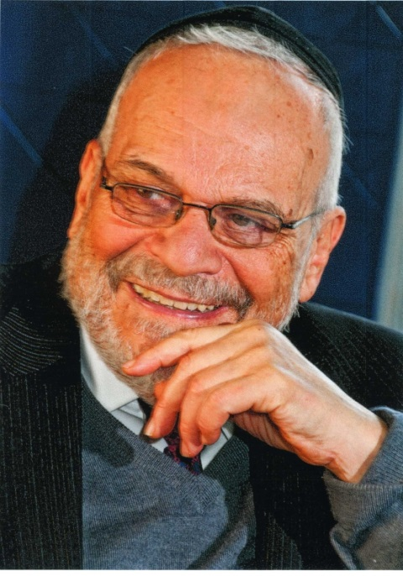
Rabbi Berel Wein

The book of Esther promised us that the days of Purim would not pass from the Jewish people for all of its generations. The rabbis of the Talmud even stated that all of the holidays of the Jewish year would not necessarily be celebrated in the messianic era but that the holiday of Purim would remain eternally.
At first glance, this seems to be a very strange observation. Purim ostensibly symbolizes the miraculous survival of the Jewish people throughout ages of persecution and genocide. In the messianic era such cruelties will no longer exist, for nations will not bear swords against one another nor shall they continue to teach and train for war.
In such an idyllic situation, why should we continually be reminded of past difficulties and tragedies? Even if we should recall our deliverance and salvation, recalling what we were saved from also forces us to remember the dangers that we were in and the terrible challenges that we had to face. Recalling deliverance always means recalling what we were delivered from.
As such these types of memories are at best bittersweet and at worst still frightening and damaging to our psyche. It seems obvious that the rabbis intended to remind us that even when danger is past and deliverance is constantly at hand, we should never forget what our experiences in history have been. Even in the messianic era the Jewish people will be shaped by the experience of the exile and its burdensome effect on Jewish tradition and spirit.
Many times in life it is not the destination that we reach that is as important as the journey that we took to reach it. No messianic era can be appreciated without recalling the process and story as to how it was achieved. Without such recall and memory the messianic era would be quite bland and dull.
Purim is exciting and joyous for us because of our near escape from annihilation and destruction. I remember, as I am sure many of you do as well especially if you are of my generation, the joy and relief that was experienced by the Jewish people at the successful and what was then seen as miraculous victory of Israel over mighty Arab forces in the Six-Day War of 1967.
It was the fear and trepidation, the danger of annihilation that gripped the Jewish people for the weeks before the war that made the Israeli victory so meaningful and memorable to those of us were fortunate enough to be alive at that time. The same thing will undoubtedly be true of the messianic era. People take everything for granted and rarely stop to think about the events and the consequences of our behavior.
The messianic era cannot occur in a vacuum. It is a process built upon past experience and history. It certainly cannot be placed into context and truly understood and contemplated by humanity if what led to it is ignored or unknown. Purim remains as the eternal reminder, the necessary preface to understand and appreciate deliverance and messianic blessing. Until the full arrival of the messianic era, Purim serves to remind us as to the precarious nature of the world that we live in.
During the Passover Seder night we will remind ourselves of the bitter fact that in every generation there are enemies who seek our destruction and that it is only through Divine intervention that we have survived till this day. This is a reinforcement of part of the Purim message to us.
Haman is not a one-time phenomenon and so many times in history these plans have been foiled and all of the Hamans themselves meet a bitter end. There always arises someone else to take his place and to follow his murderous policies. It is beyond my ability to explain this or to understand it, yet it is one of the clearest and most repeated facets of human history on record.
There are many reasons given both in the Jewish and general world for the persistence of anti-Semitism, the most ancient of all diseases in society. None of them are rational on their own but that has nothing to do with facts or reason. As such it is unlikely to expect that in the pre-messianic world that we live in, anti-Semitism will disappear of its own accord. But we Jews can take heart from the story of Purim that all will be well at the end and that the joy of Purim will never depart from us and our descendants.

Reprinted from the Purim 5778 website of Rabbiwein.com

A Unique Megillah Question
By R’ Shmuel Winzelberg

'If it pleases the king, let it be written to destroy them…' (Esther 3:9)

R’ Chaim Volozhiner, zt”l, was accustomed to sitting at the head of the table for his Purim Seudah. He carried a sack of coins that he gave out to the poor and needy. No one was ever turned away.
One Purim an old man with a long flowing white beard accepted a coin from R’ Chaim. He hesitated a moment, gathered up his courage, and asked for another coin.
“If the Rav will be so kind as to offer me another coin,” said the old man, “I will tell him a chiddush, a novel thought that I am pretty sure even the great R’ Chaim Volozhiner has never heard!”
R’ Chaim raised an eyebrow in surprise, but moved by the Purim spirit, gave the old man another coin. The old man joyously accepted the coin and asked the following question:
The Yalkut Shimoni describes where Eliyahu HaNavi came to Mordechai and revealed to him that the deadly decree forced upon the Jews was within his reach and he had the ability to repeal it.
Eliyahu HaNavi explained that the Heavenly decree was not written in blood, which would have sealed the Jews’ fate for good. Rather, it was encrusted in cement, and with the power of tefilah and teshuvah of Bnei Yisroel, there was a chance that they would be saved.
The old man faced R’ Chaim and asked, “My question is, where is this concept hidden in the words of the Megillah?”
All the guests at the table held their breath in anticipation. R’ Chaim closed his eyes, creased his brow and was deep in thought. After a few moments he opened his eyes, smiled and admitted defeat.
“Please tell me the answer to your question,” said R’ Chaim.
The old man smiled and said, “There is an opinion that states that every time the word Ha'melech, the king, is written in the Megillah, it is a reference to HaKadosh Baruch Hu, the King of all kings. When Haman approached Achashverosh with his proposal, he said the following (Esther 3:9): "If it is good before the king, he shall write to destroy them'.
“If we look carefully at the words, however, the word 'לאבדם 'can be split into two words: 'בדם לא' ,'not with blood', and the meaning of the pasuk would then be 'טוב המלך על אם' ,'If it is proper before the King— Hashem', 'יכתב' ,'He will inscribe the heavenly decree', 'בדם לא' ,'not with blood'— but rather in cement!
R’ Chaim cried out with joy after hearing this truly novel chiddush. Later, upon visiting his rebbe, the Vilna Gaon, zt”l, R’ Chaim told over the chiddush.
The Vilna Gaon told him that the old man could have been none other than Eliyahu HaNavi! (Torah Tavlin)

Reprinted from the Purim 5771 email of Torah U’Tefilah compiled by Rabbi Yehuda Winzelberg.

A ‘Wild West’ North Dakota Litvishe Rov’s Purim Legacy

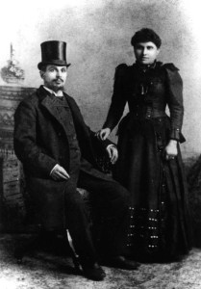
Reverend” Benjamin Papermaster & Anna Levito’s
Wedding Photo at Grand Forks, North Dakota, 1892
A young Lithuanian rov arrives in a Wild West frontier town, some 7,000 miles from his home and his family, with only a Torah scroll and a few sparse belongings in his possession. Four generations later, his great-great-grandson returns to help bring Purim to his forbearer’s city.
The rabbi was Rabbi Binyomin Papermaster.
As his son Isadore Papermaster would later recount in a lengthy letter about his father’s life: “How and why a young man, reared and trained for the rabbinate in the most Orthodox Lithuanian Jewish community of Kovno, under the guidance of the then famous Rabbi Yitzch[ak] Elchanan [Spektor, the chief rabbi of Kovno], was transported to the vast open prairies of North Dakota in 1890 and remained there approximately 45 years of his life in the service of his calling and his people” is a story of Jewish tenacity in America.
Born in November of 1860, the seventh of nine children to Nissen and Etel Papermeister of Anolova, Lithuania, Papermaster studied in the famed Slobodka Yeshiva.
When the Jewish community of Fargo, N.D., reached out to Spektor, the esteemed rabbi looked to one person: Papermaster. Trained not only as a rabbi but also as a shochet (a ritual slaughterer) and mohel (a circumciser), the recently married Papermaster was ideally suited for the position far from the Jewish establishment.
Papermaster arrived in Fargo in late 1890. There, he found a group of 15 Jewish settlers and their families who were tenaciously trying to settle the windswept prairie. The local Jews, however, were uninterested in the Eastern European rabbi and more concerned with farming the often harsh environment, in addition to assimilating into their newfound American culture.
Despite the pleas of family in New York to abandon North Dakota, Papermaster felt that he was tasked with a holy mission to serve the community.
A few months after his arrival, the rabbi learned of the tragic passing of his wife, Ethel, back in Lithuania. Nevertheless, he felt he could not leave his post.
As his son Isadore would later write: “One thing he was certain of … that his future was bound up with this country to which he had just come, and he began to look about for the possibility of making change.”
Arrangements were made for his four young sons, the eldest only 8 and the youngest just 1, to come to America.
Not long afterwards, Papermaster relocated to Grand Forks-75 miles north of Fargo and home to some 60 Jewish families-where the Jews were far more traditional in their practice.
The rabbi later remarried Anna (Chaya) Leviton, and they had four sons.

‘The Guiding Spirit’
Community members would later recount the early tensions between the young Lithuanian rabbi and a congregation that was largely Chassidic in origin. Their customs and traditions differed from his own; even their language was not entirely the same. Coming largely from “Russia”– Galicia and Western Ukraine–many of the local Jews spoke with the earthier southern dialect, while Papermaster spoke with the clipped northern Yiddish of Lithuania.
Isadore recalls one particular episode his father recounted with amusement, which was indicative of this cultural divide.
Attending the Passover seder at the home of a host family, Papermaster took a place by the table, fully expecting the head of the household, Nathan Greenberg, to lead.
Some time passed; Papermaster noticed those gathered anxiously whispering to each other. Turning to his host, he asked what they were waiting for.
“Well, we are waiting for you, as the rabbi, to conduct the seder service,” went the reply.
“In that case,” Papermaster countered, “let us set the table.” Pulling up a normal chair, he waited for everyone to be seated. A new issue arose. His guests expected him to don the white robe and fur hat of a Chassidic rebbe. Papermaster would have none of it; after some negotiation, the seder began in earnest.
Word quickly spread that the new rabbi was leading the seder at the Greenbergs, attracting throngs of community members who wished to see it for themselves.
“The younger people,” Isadore recalls, “were delighted,” while the older generation grumbled that “the Litvak” (the Lithuanian) would destroy Judaism in the community.
Always pragmatic, Papermaster realized that he would need to adapt to some of the Chassidic customs of his community, as well as to reach out to those who were not nearly as observant, and far from traditional Judaism of any kind.
As he related in his speech the next day, he had promised Rabbi Spektor to bring Judaism to the community where he settled. While his commitment to biblical, talmudic and rabbinic decrees would remain steadfast and strong, he would do his utmost to “reach and preach the Jewish way of life as he understood it, and make it available to all Jews who came under his jurisdiction.”
“I may say without fear of contradiction,” Isadore later wrote, “that this principle was the guiding spirit of his entire career.”
Papermaster would remain in North Dakota for the rest of his life. Until his passing on Sept. 24, 1934, he traveled to outlying Jewish communities in the state’s various small settlements, officiating at weddings, circumcisions and funerals.
‘Larger-Than-Life Story’
Some 80 years after Papermaster’s passing, his great-great-grandson Rabbi Menachem Orenstein, 24, will be returning to North Dakota.
Orenstein, who along with his brothers is the first generation of Papermaster’s descendants to be ordained as a rabbi, says he is excited about the chance to explore his great-great-grandfather’s history.
“Growing up, the idea that we came from this rabbi who served as the chief rabbi of North Dakota was this larger-than-life story we heard,” he relates.

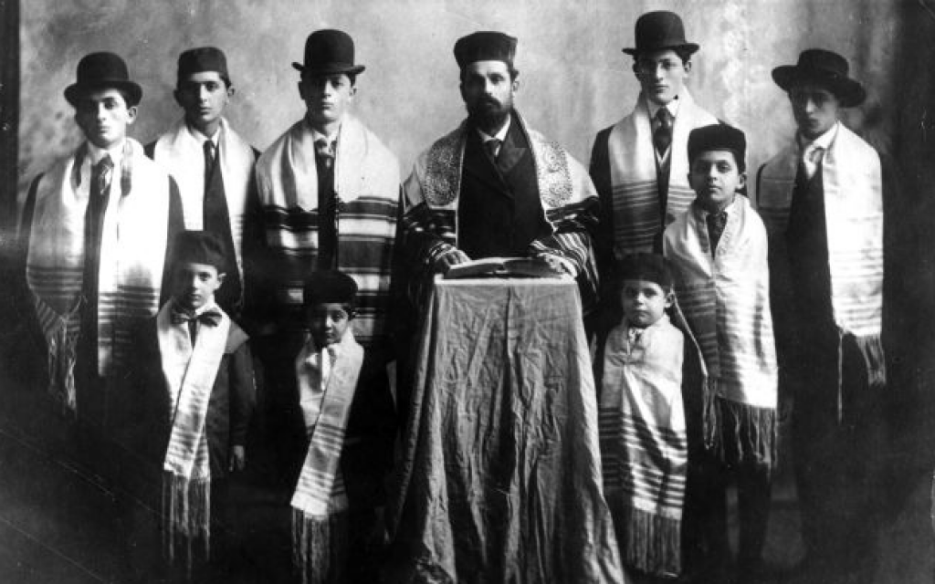
Rabbi Benjamin Papermaster and his eight sons and first grandson in Grand Forks, North Dakota, 1908. (The Jewish Museum of the American West)

Orenstein first came to North Dakota as “Roving Rabbi” three years ago to
help Rabbi Yonah Grossbaum, co-director of the Chabad Jewish Center of North Dakota in Fargo, the sole Chabad-Lubavitch emissary in the state.
The experience inspired Orenstein to look further into his family’s history. Now, returning to the state once more for a whirlwind Purim-day tour that will bring him to Fargo, Bismarck and Grand Forks, Orenstein is excited to dig a little deeper than before.
“He was such a unique person,” says Orenstein. “To dedicate your life to Jews in such a far-flung community then, you don’t often hear stories like that.”
Orenstein isn’t the only one enthusiastic about visiting North Dakota. Resident community members have taken note as well.
Kenneth Dawes, 78, a native of Grand Forks and a retired professor at the University of North Dakota, grew up in a home once owned by the rabbi. In fact, one of the courses he taught is titled “Rabbi Benjamin Papermaster and the Jewish Community in Early Grand Forks.”
According to Dawes, the Jewish community of Grand Forks reached its zenith during the early 20th century. After World War II, however, as young Jews were attracted to business opportunities elsewhere and the promise of stronger communal life in cities like Minneapolis-St. Paul and Chicago, Grand Fork’s Jewish population began to dwindle.
Despite being born shortly after Papermaster’s passing, Dawes recalls the aura of the “pioneer in rabbi in the heart of North Dakota,” which lingered within the community.
Not only that, during the Great Depression Dawes’ parents were in need of a home for their growing family. Approaching Papermaster about an apartment he owned, Dawes’ mother was hesitant to mention the size of her family.
“We were five children at that time,” says Dawes. “She was worried he wouldn’t want to rent to such a large family.”
The rabbi’s remark, however, immediately set her at ease. ” ‘Children,’ ” Dawes remembers his mother relating, “‘have to live, too.’ ”
So impressed was Dawes’ mother by the rabbi’s response that for years to come, she would recount it to her family as an example of his modest and loving nature.
As to Orenstein’s visit, Dawes takes interest in the continuity of the family legacy.
“His great-great-grandfather’s memory is one that has gone down in the memory of the history of Grand Forks,” states Dawes.
Orenstein is of like mind: “I’m fascinated by my great-great-grandfather’s history. But on this trip, I see it as something far more powerful: By traveling to North Dakota, by coming here to help spread Jewish knowledge for the holiday of Purim, I’m perpetuating his legacy. This is what he would want.”

Reprinted from the March 5, 2015 website of Matzav.com Reprinted from Chabad.Org

